**Project Documentation: Corner Grocer Item Tracking Program**

**Overview**: This program is designed to help the Corner Grocer analyze the items purchased throughout the day. It reads a list of items from a text file, tracks their frequencies, and provides various functionalities to display this information.

**Features**:

1. **Look up frequency of a specific item**:
   * Prompts the user to enter an item name.
   * Displays the frequency of the specified item.
2. **Print all item frequencies**:
   * Displays a list of all items along with their frequencies.
3. **Print histogram of item frequencies**:
   * Displays a text-based histogram where each item is followed by asterisks representing its frequency.
4. **Exit the program**:
   * Allows the user to exit the program gracefully.

**Data Backup**:

* The program creates a backup file (frequency.dat) that contains the frequency of each item.

**Class Usage**:

* The program utilizes a map (associative array) to store item frequencies, which is efficient for counting and retrieving item occurrences.

**Best Practices**:

* The code follows industry-standard best practices with meaningful variable names, in-line comments, and clear code structure.

**Screenshots**:

1. **Menu Display**:

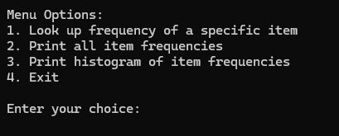

1. **Frequency Lookup**:

1. **All Frequencies**:

1. **Histogram**:

**Code Highlights**:

* The program reads item frequencies from an input file and stores them in a map.
* It includes functions for looking up specific item frequencies, printing all frequencies, and printing a histogram.
* User input is validated to ensure robustness.
* Item frequencies are backed up in a frequency.dat file for persistence.

**Explanation of Input Validation:**

1. **Validate Menu Choice**:
   * Use cin.fail() to check if the input is not an integer.
   * Use cin.clear() to clear the error flag on cin.
   * Use cin.ignore() to discard the invalid input.
   * Ensure the choice is between 1 and 4.

**Running the Program:**

1. **Build and Run**:
   * Save your changes.
   * Click on Build > Build Solution to compile the code.
   * Click on Debug > Start Without Debugging to run the program.
2. **Testing**:
   * Test each menu option to ensure it works as expected with input validation.
   * Check the contents of frequency.dat to ensure it has the correct data.